3rd Assignment Day 6 | 7th December 2020

Question

1. Use ps to search for the “systemd” process by name.

2. Find out your terminal name.Using your terminal name, use ps to find all processes associated

With your terminal.

3. Check and note the process id of your shell(from the output of the above command).

Also, note the parent process id of your shell.

4. Start 3 instances of “sleep 123” as background processes.

5. Check and note the process id’s of all sleep processes.

6. Display only those three sleep processes in top. Then quit top.

Answer

1. Use ps to search for the “systemd” process by name.

Using **ps -ef | grep systemd**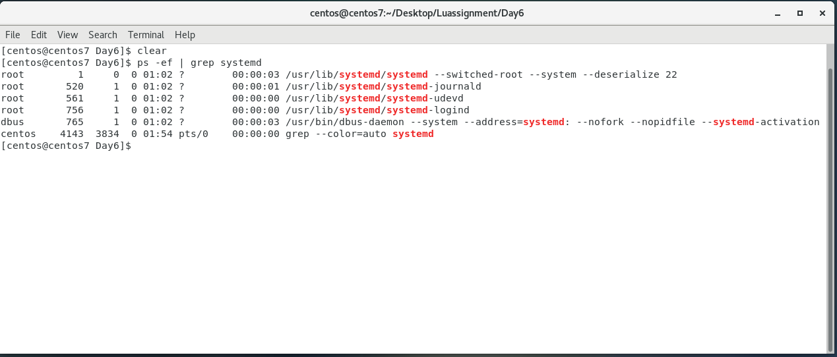

2. Find out your terminal name.Using your terminal name, use ps to find all processes associated

Using **uname -a**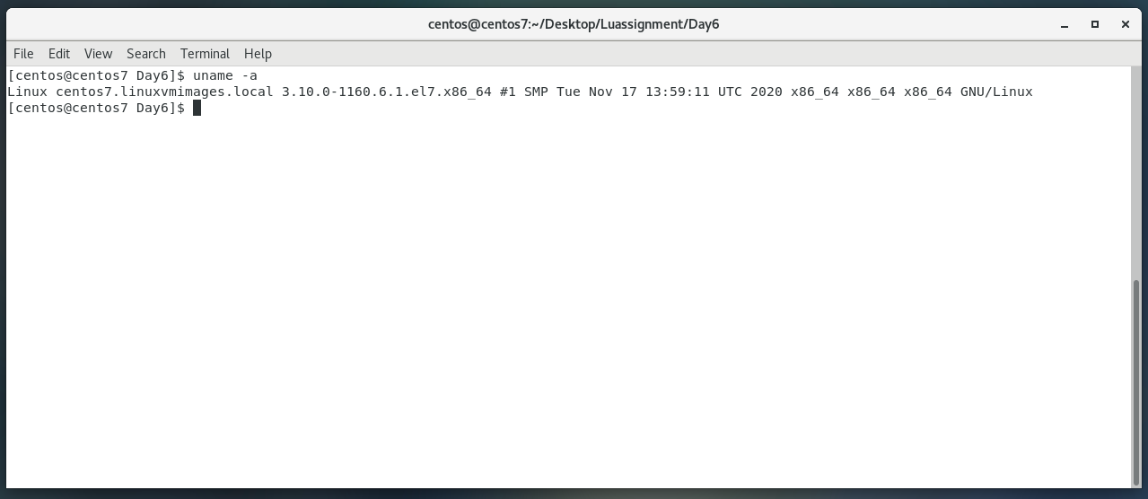

Using **ps** **-ef** to find all processes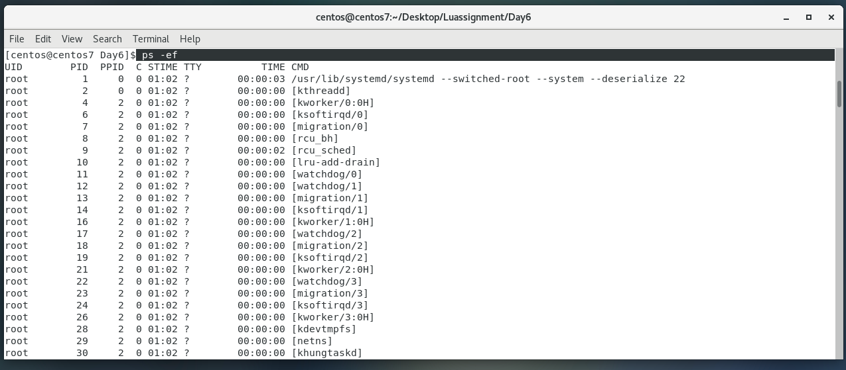

3. Check and note the process id of your shell(from the output of the above command).

Also, note the parent process id of your shell.

Using **ps -fp $$** to get process id(**PID**) of the shell and also the parent process(**PPID**)

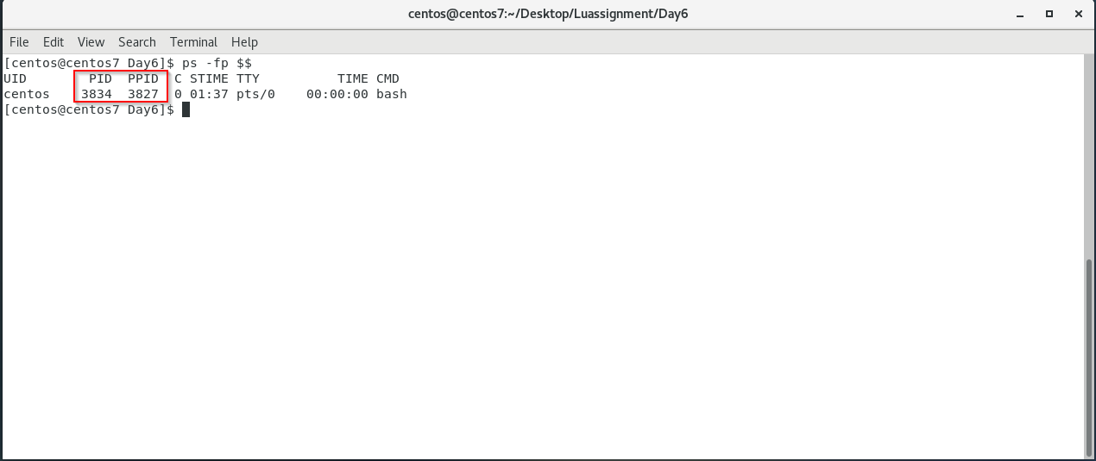

4. Start 3 instances of “sleep 123” as background processes.

create 3 instances of “sleep 123” as the background processes by using the command sleep 123 & three times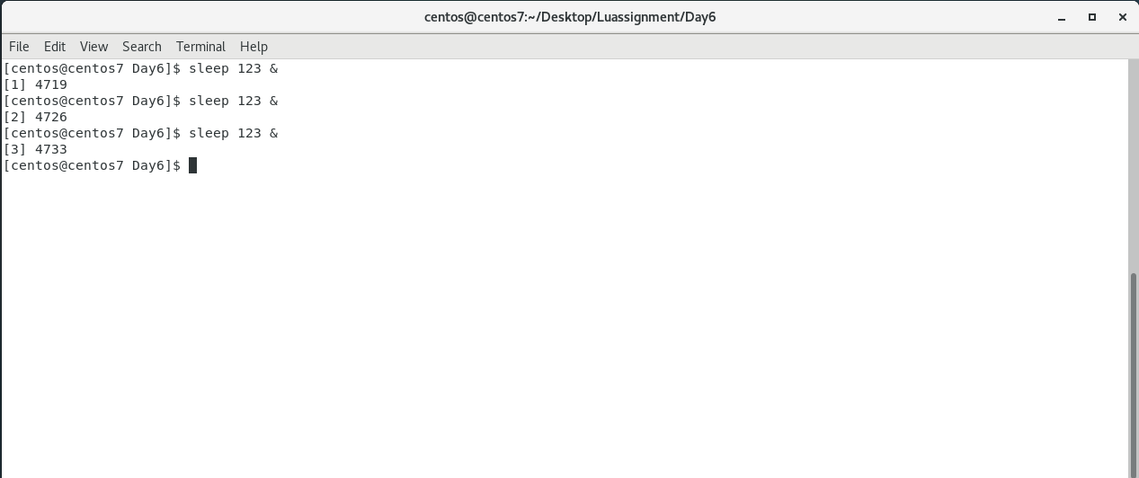

5. Check and note the process id’s of all sleep processes.

using the command **ps -C sleep** or **ps -fC sleep**

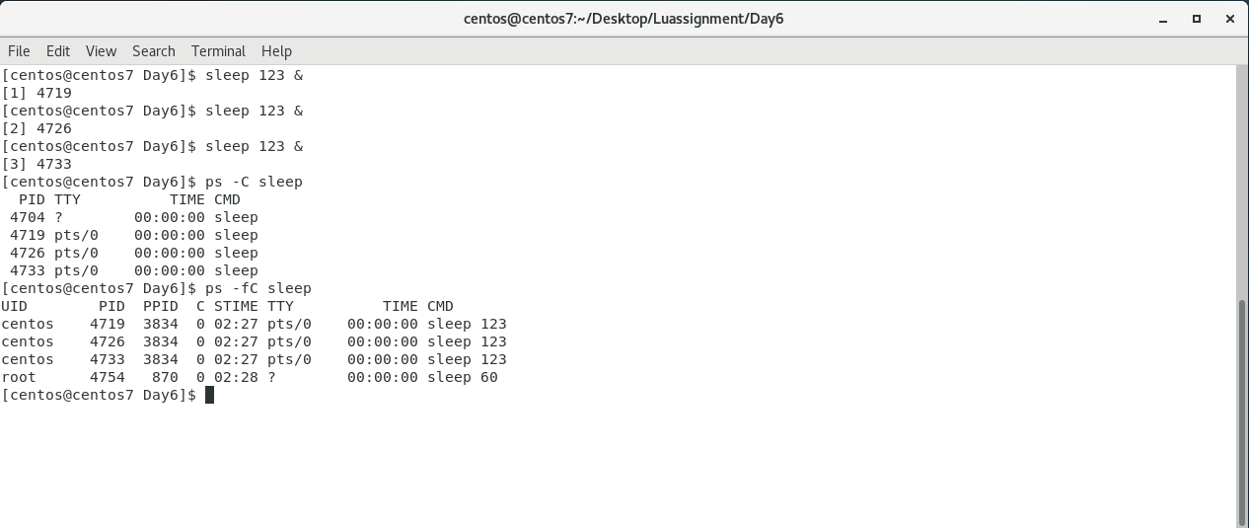

6. Display only those three sleep processes in top. Then quit top

use **top -b | grep sleep** to get the three sleep processes in top and then we quit by pressing **ctrl + C**.

